Appendix EA 3-1: Analytical Methods

Lithogeochemistry of intrusive suites
Thirty-six samples of least- to highly altered intrusive rock were sent to Activation Laboratories in Ancaster, Ontario for crushing, pulverising, and whole-rock geochemical analysis. The analytical package used was 4Lithoresearch (Fusion XRF and ICP-OES). Lab certificates and QA-QC of the output data indicate no analytical issues for the results presented herein. Estimates of the errors for the major and minor elements are 0.5 to 10 % whereas for the trace elements it is 0.24 to 10 %.
Re-Os geochronology
Three drill core samples (Fig. A1) were prepared for mineral separation and dated using Re-Os geochronology techniques at the University of Alberta Radiogenic Isotope Facility, in Edmonton, Alberta, Canada. A molybdenite mineral separate was created for each sample through metal-free crushing followed by gravity and magnetic concentration methods described in Selby and Creaser (2004). The ¹⁸⁷Re and ¹⁸⁷Os concentrations in molybdenite were determined by isotope dilution mass spectrometry using Carius-tube, solvent extraction, anion chromatography and negative thermal ionization mass spectrometry techniques.
For this work, a mixed double spike containing known amounts of isotopically enriched ¹⁸⁵Re, ¹⁹⁰Os, and ¹⁸⁸Os analysis was used (Markey et al., 2007). Isotopic analysis used a ThermoScientific Triton mass spectrometer by Faraday collector. Total procedural blanks for Re and Os are less than <3 picograms and 2 picograms, respectively, which are insignificant in comparison to the Re and Os concentrations in molybdenite. The Reference Material 8599 Henderson molybdenite (Markey et al., 2007) is routinely analyzed as a standard, and during the past 2 years returned an average Re-Os date of 27.77 ± 0.07 Ma (n=10), indistinguishable from the Reference Age Value of 27.66 ± 0.1 Ma (Wise and Watters, 2011). The ¹⁸⁷Re decay constant used is 1.666e-11.a-1 (Smoliar et al, 1996).
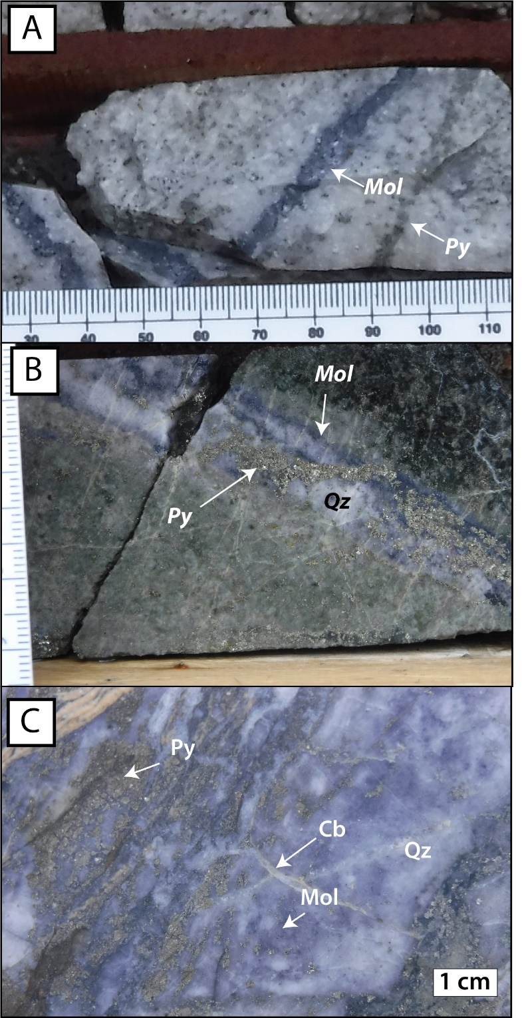
Figure A1: Images of the molybdenite vein samples collected from drill-core used for Re-Os geochronology. A. Sample CYWS17-01 (CD-09; 170 m). B. Sample KZWS17-128 (KL-16-309; 407 m). C. Sample KZWS19-20 (KL-16-314; 431 m). Mineral abbreviations in accordance with Whitney and Evans (2010).
References:
Markey, R., Stein, H. J., Hannah, J. L., Selby, D., and Creaser, R. A., 2007, Standardizing Re-Os geochronology: A new molybdenite Reference Material (Henderson, USA) and the stoichiometry of Os salts: Chemical Geology, v. 244, p. 74-87.
Selby, D. and Creaser, R. A., 2004, Macroscale NTIMS and microscale LA-MC-ICP-MS Re-Os isotopic analysis of molybdenite: Testing spatial restrictions for reliable Re-Os age determinations, and implications for the decoupling of Re and Os within molybdenite: Geochimica et Cosmochimica Acta, v. 68, p. 3897-3908.
Smoliar et al., 1996, Re-Os ages of group IIA, IIIA, IVA, IVB iron meteorites: Science, v. 271, p. 1099-1102.
Whitney, D.L. and Evans, B.W., 2010. Abbreviations for names of rock-forming minerals. American Mineralogist, v. 95, pp. 185-187.
Wise, S. A., and Watters, R. L., 2011, Reference Material 8599 Henderson Molybdenite: National Institute of Standards and Technology Report of Investigation, 30 March 2011.

